**Excel Tasks:**

1. **Data Exploration:**

Task 1: Create a statistical summary for numerical features

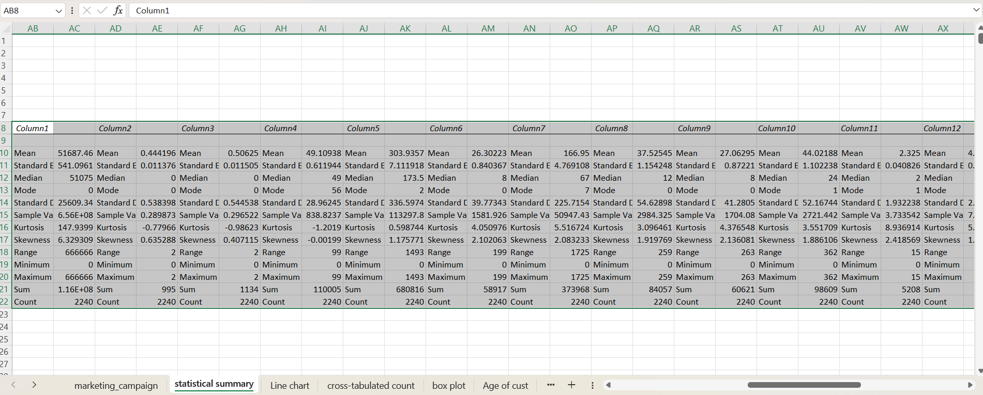

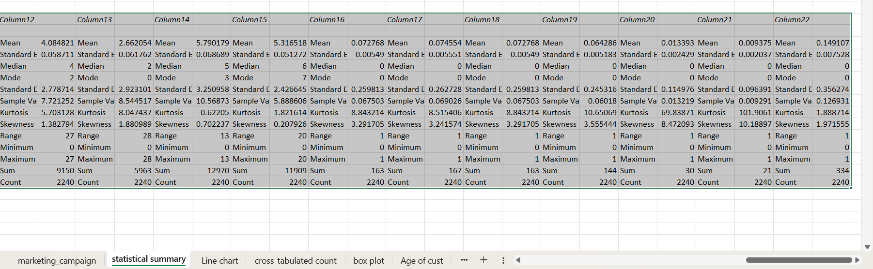

Task 2: Create a line chart for the number of enrolments by year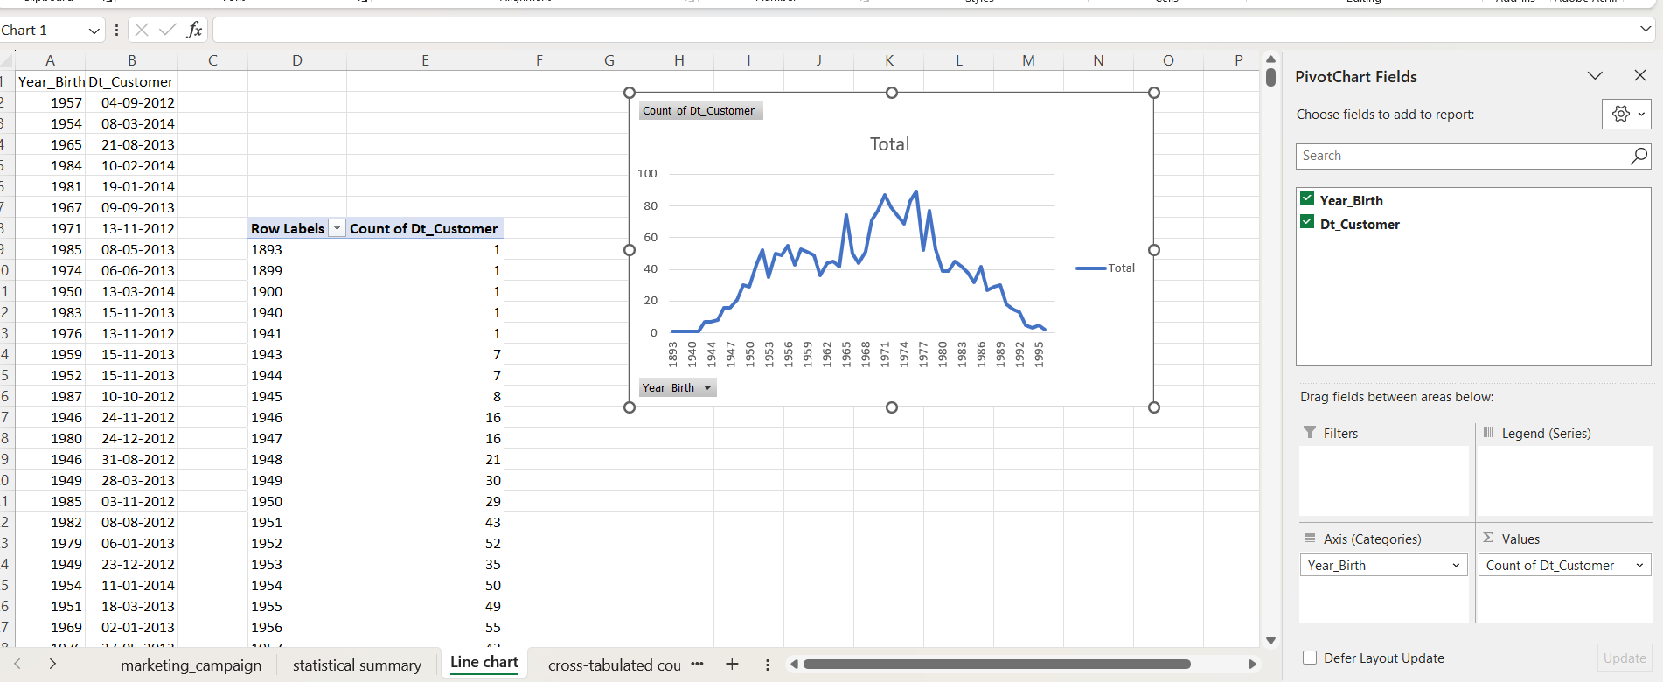

Task 3: Give a cross-tabulated count for response values against education

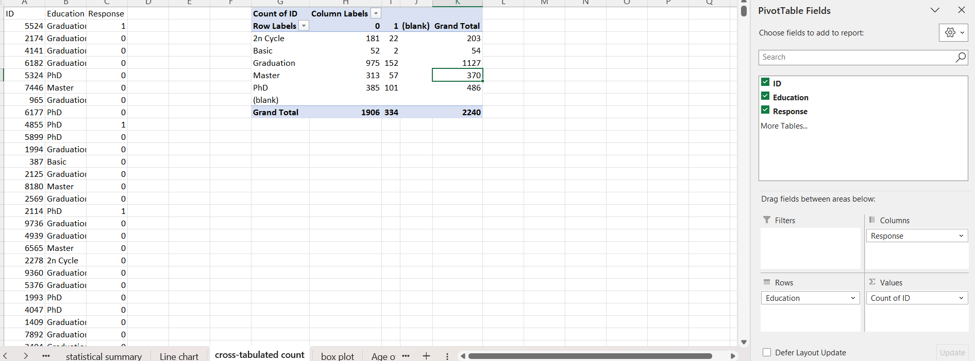

Task 4: Make a boxplot on income and write your observations

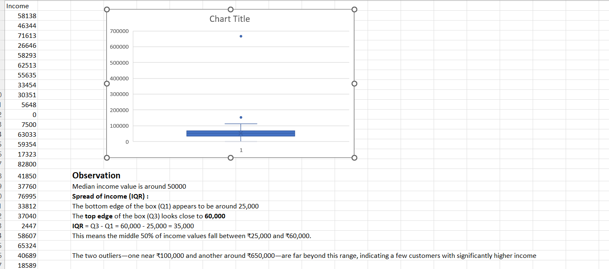

Task 5: Calculate the age of customers and make a histogram of that

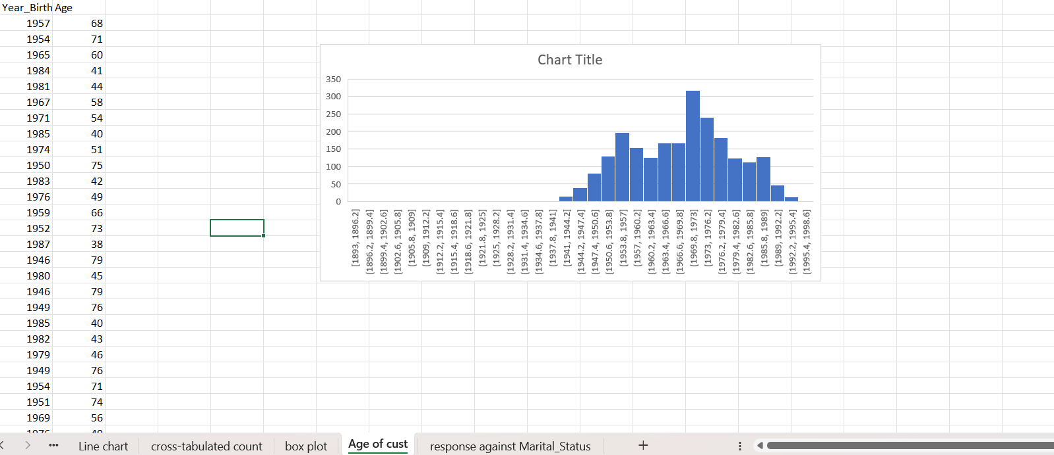

Task 6: Visualize the response against Marital_Status

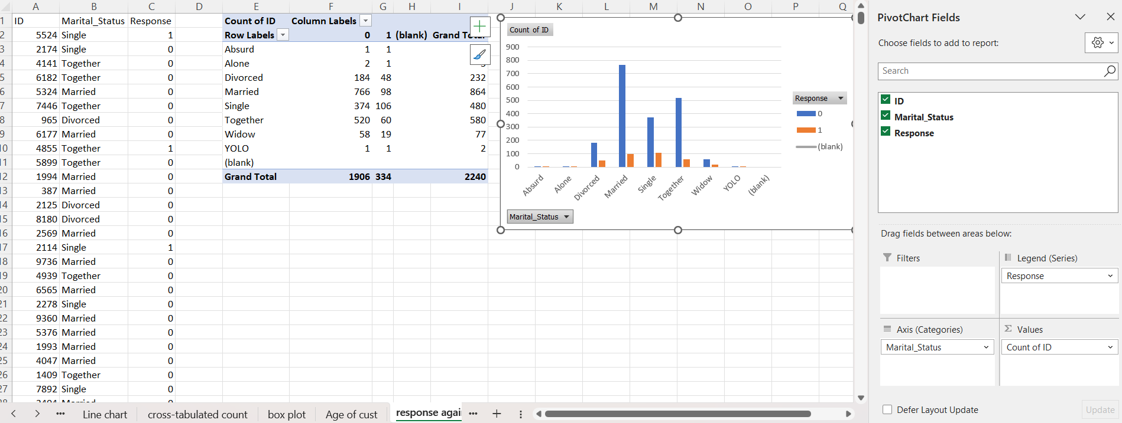

**2. SQL Task :**

**1.Data Loading:**

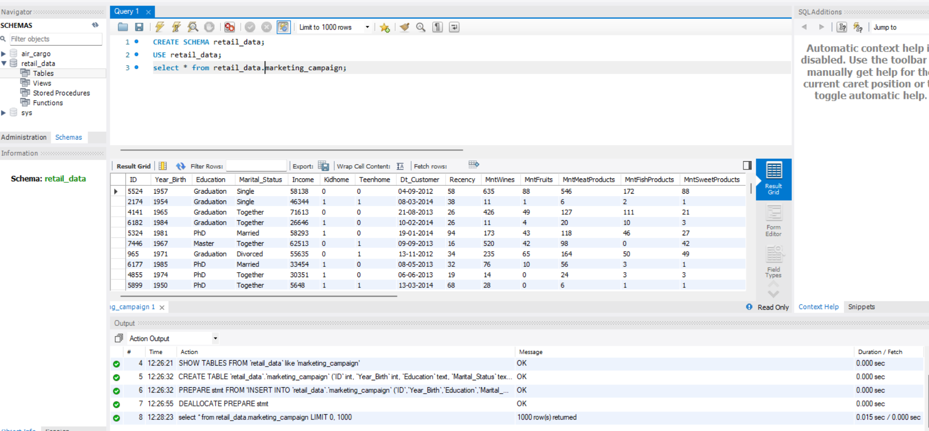

1. **Data Preprocessing:**

Calculate the total number of customer encounters in the marketing campaign dataset :

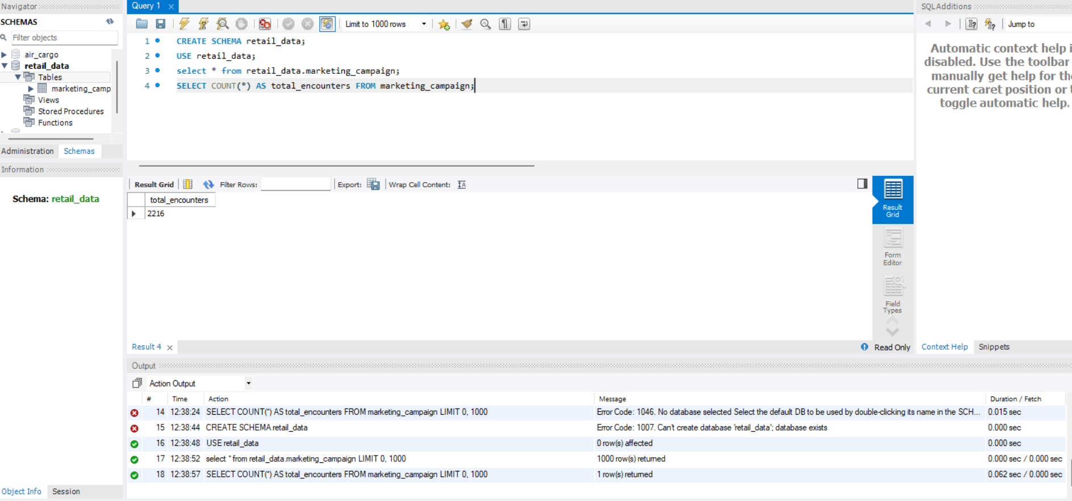

Identify the top 10 most purchased products in the dataset, such as Wines, Meat Products, etc.

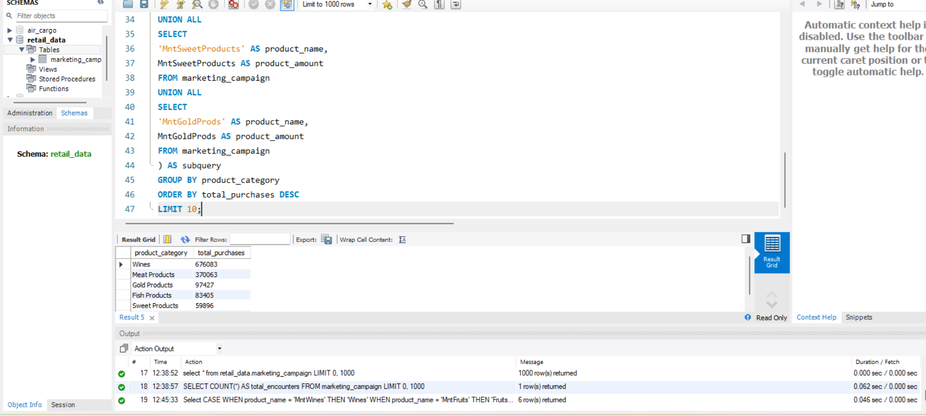

Find the count of response values

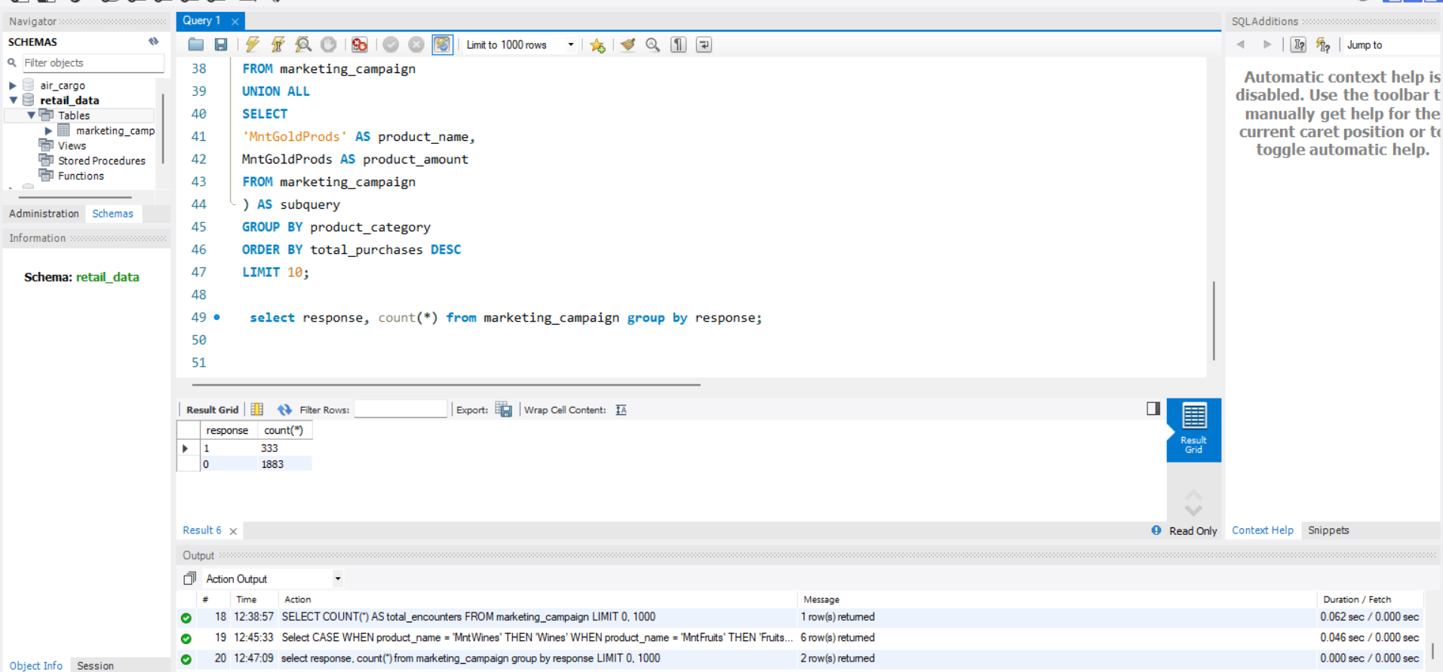

Determine the distribution of customers based on their education level and marital status

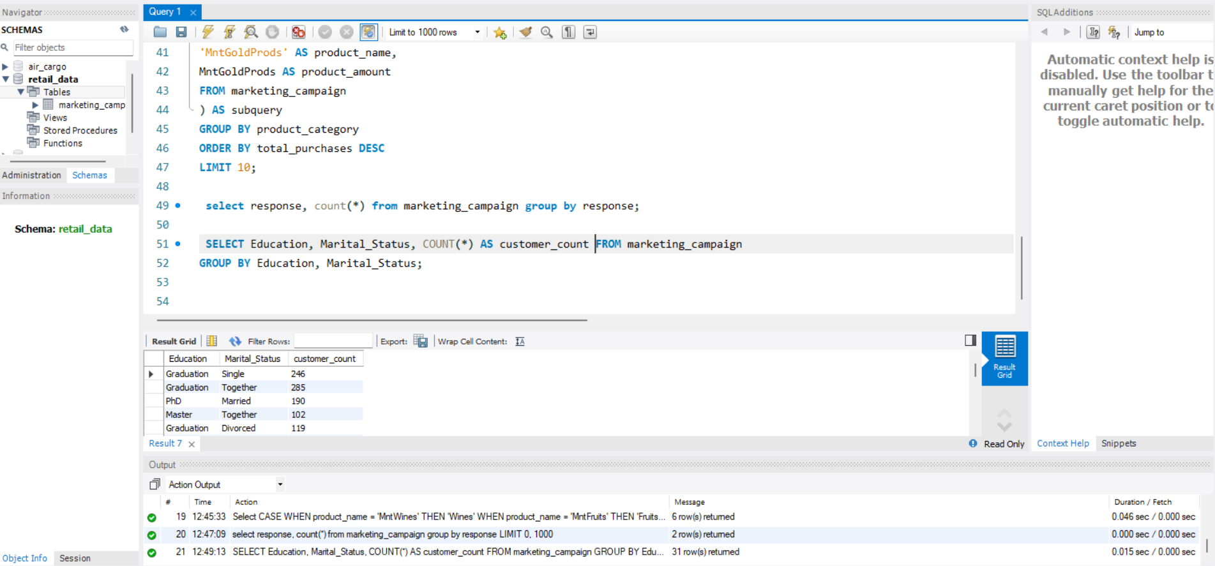

Identify the average income of customers who participated in the marketing campaign

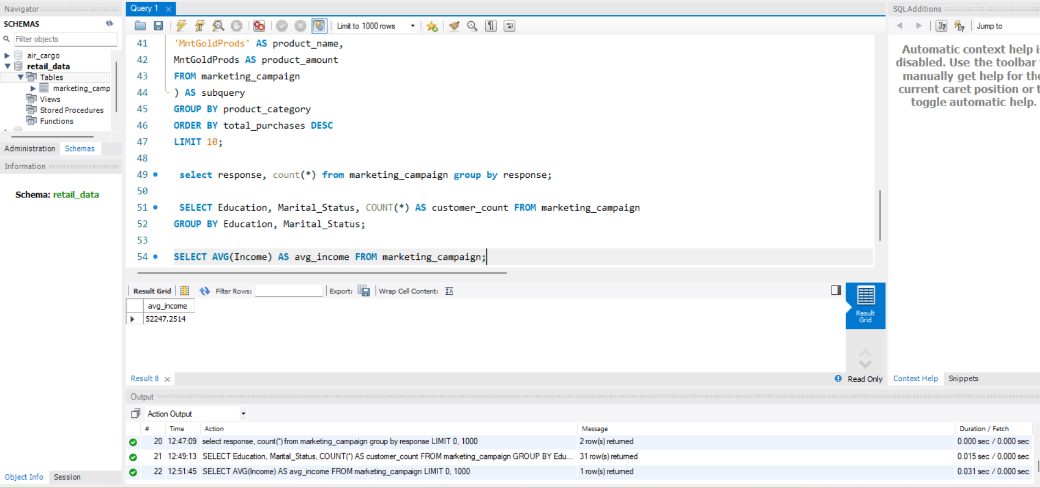

Calculate the total number of promotions accepted by customers in each campaign

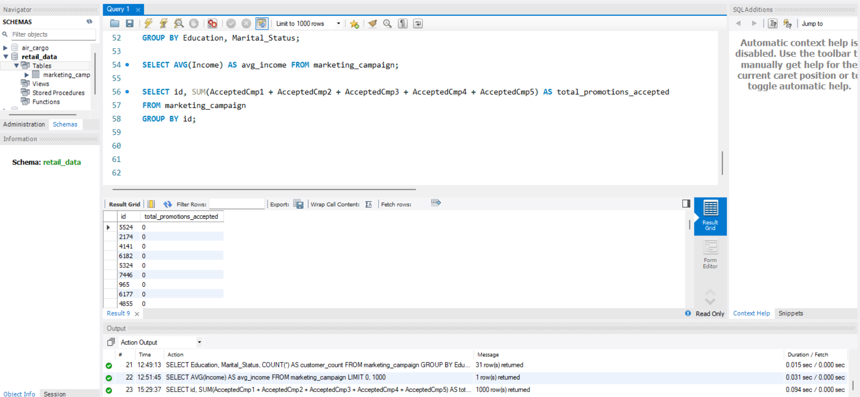

Identify the distribution of customers' responses to the last campaign

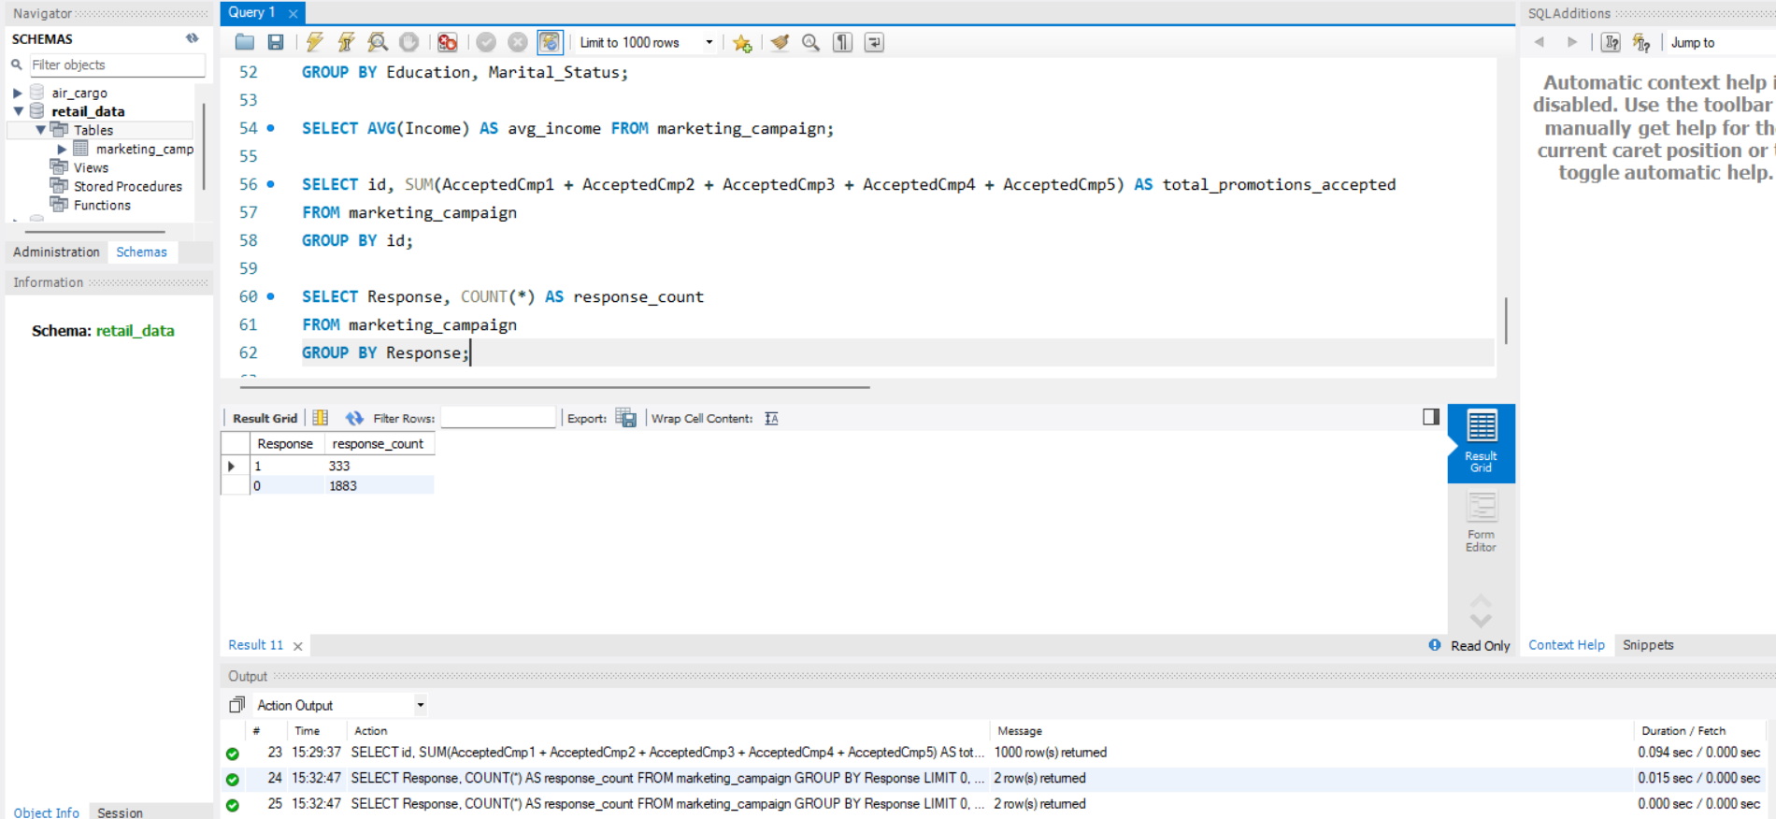

Calculate the average number of children and teenagers in customers' households

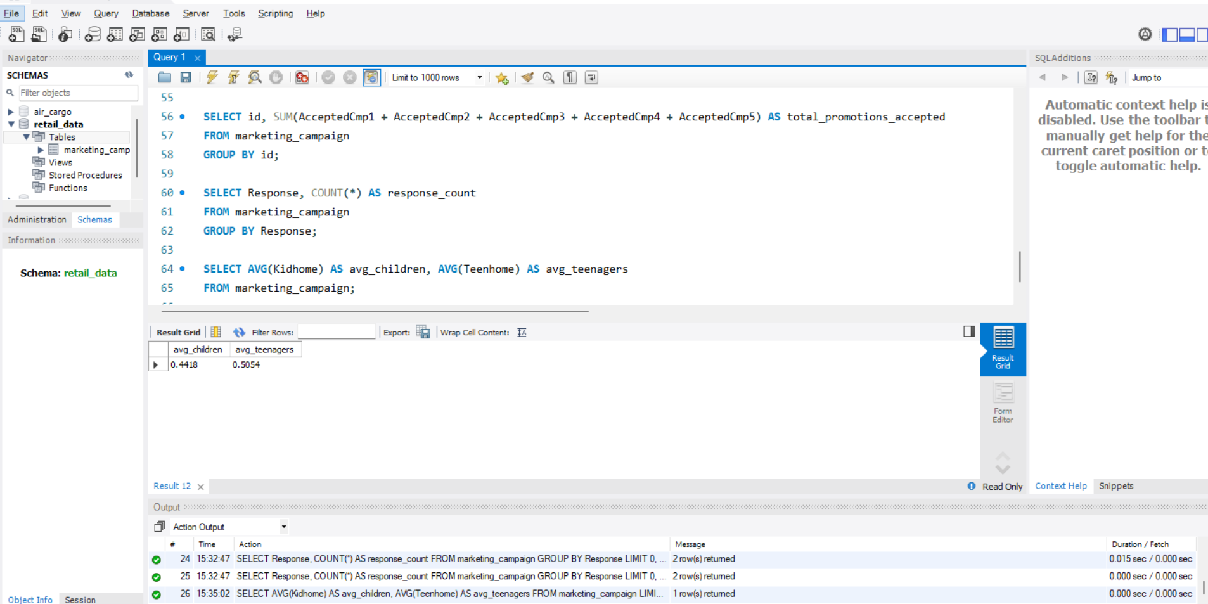

Create an Age column by subtracting year_birth from the current year

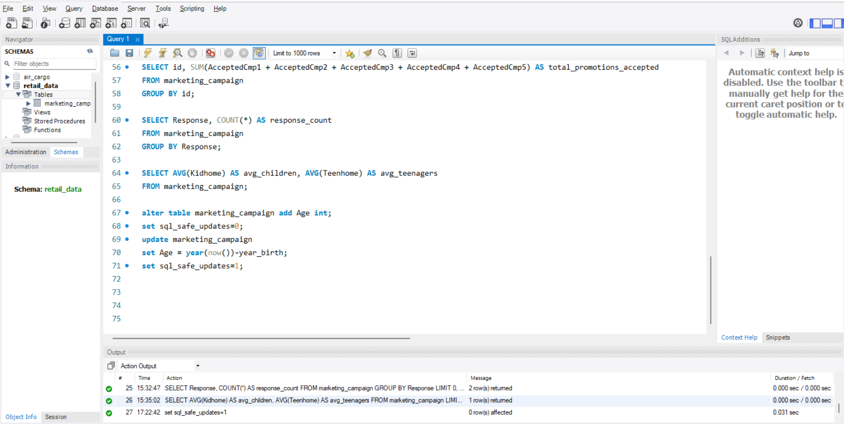

Create Age_group columns based on the below condition:

**WHEN Age BETWEEN 18 AND 25 THEN '18-25'**

**WHEN Age BETWEEN 26 AND 35 THEN '26-35'**

**WHEN Age BETWEEN 36 AND 45 THEN '36-45'**

**WHEN Age BETWEEN 46 AND 55 THEN '46-55'**

**ELSE '56+'**

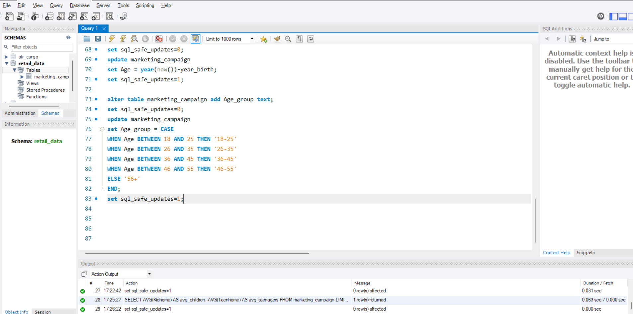

Determine the average number of visits per month for customers in each age group by using the following query:

